Lesson 17 Practice Project: Enhancing Academic Data Insights Through SQL Views and CTEs

- Creating Tables in SQLite
Create a new database - First, I created a new SQLite database (named UniversityDB) using DBeaver. I opened the New Database Connection window, selected SQLite as the database type, and chose a file location and name for the database file. After clicking Finish, DBeaver created an empty database and connected to it.
- Create the Students table
Next, I opened a new SQL Editor window for this database and wrote a CREATE TABLE statement. The table has six columns: StudentID (the primary key), FirstName, LastName, DOB (date of birth), Major, and GPA.
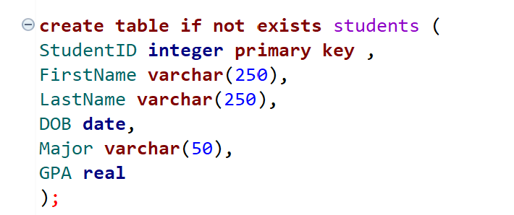
- Create the Courses table
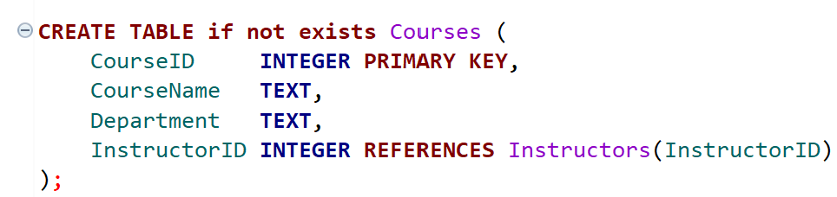
- Create the Instructors table
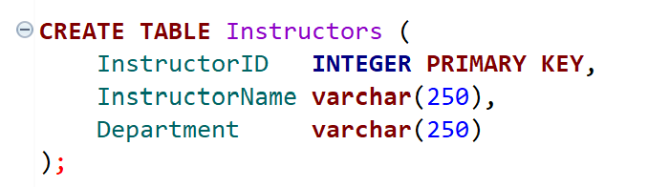
- Create the Enrollments table
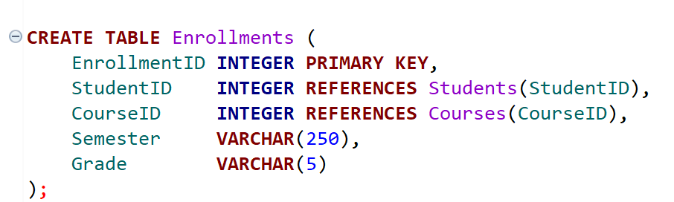

University DataBase ERD diagram
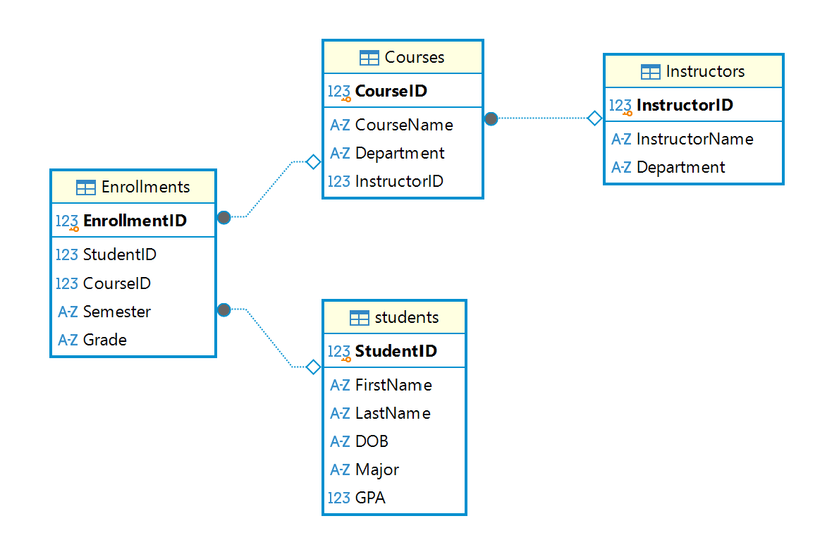

- Create a view named CourseSummary that shows the total number of students enrolled in each course
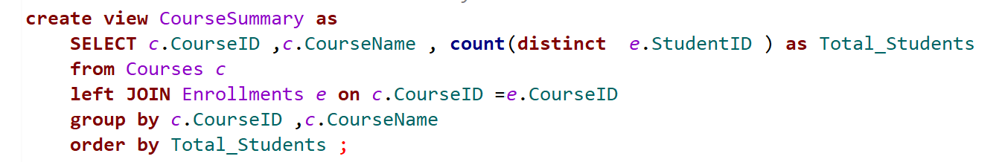
Result:
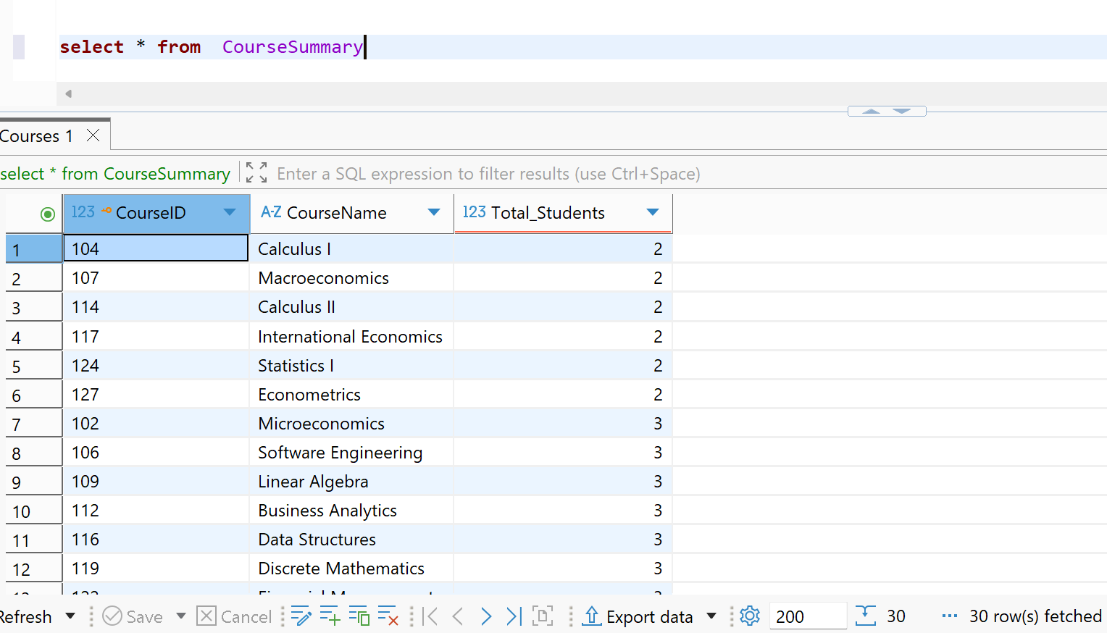

2. Create a view InstructorSchedule - Create a view InstructorSchedule that lists each instructor's courses and department
The Courses table did not have a column to link a course to an instructor. I recreated the Courses table with a new InstructorID column and added a foreign key that references InstructorID in the Instructors table. I also assigned an instructor from the matching department to each course.
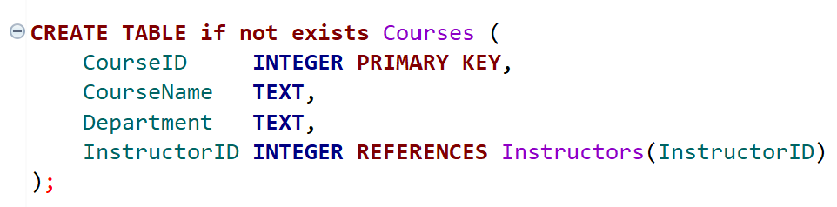
I created the InstructorSchedule view, which joins the Instructors and Courses tables and lists each instructor with their courses and department. The view returned 32 rows: 30 rows for the courses with their instructors, and 2 rows for instructors without a course. Dr. Foster (Engineering) and Dr. Wilson (Business) have NULL values in the CourseID and CourseName columns because no course is assigned to them. There are no Engineering courses in the Courses table, and the two Business courses are assigned to other Business instructors.
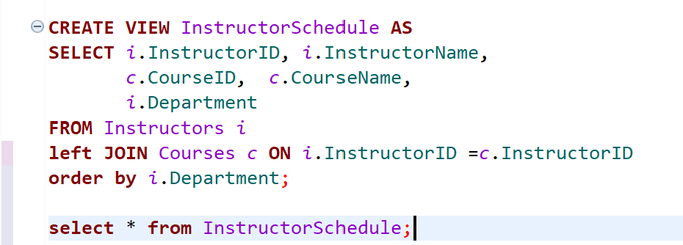

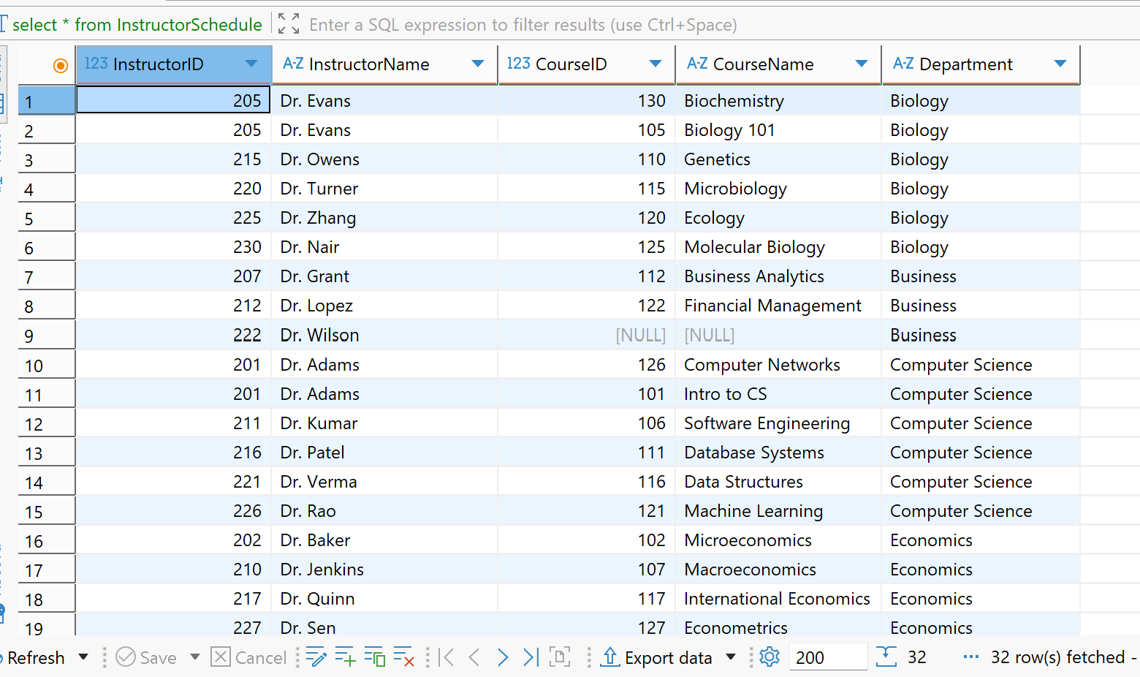

3. Modify CourseSummary - Modify the CourseSummary view to list the distinct semesters each course was offered, along with the total student enrolment
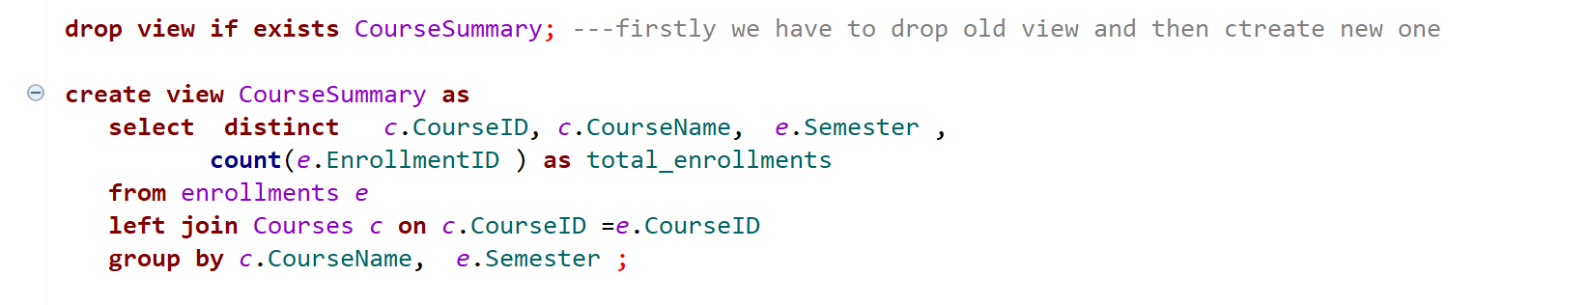
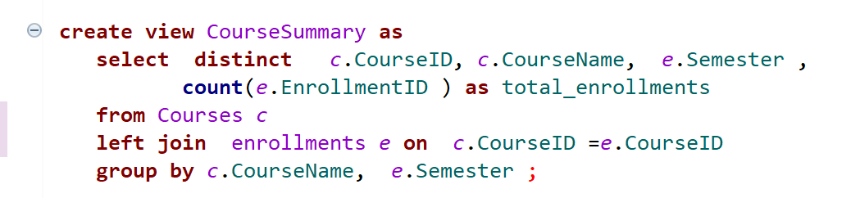
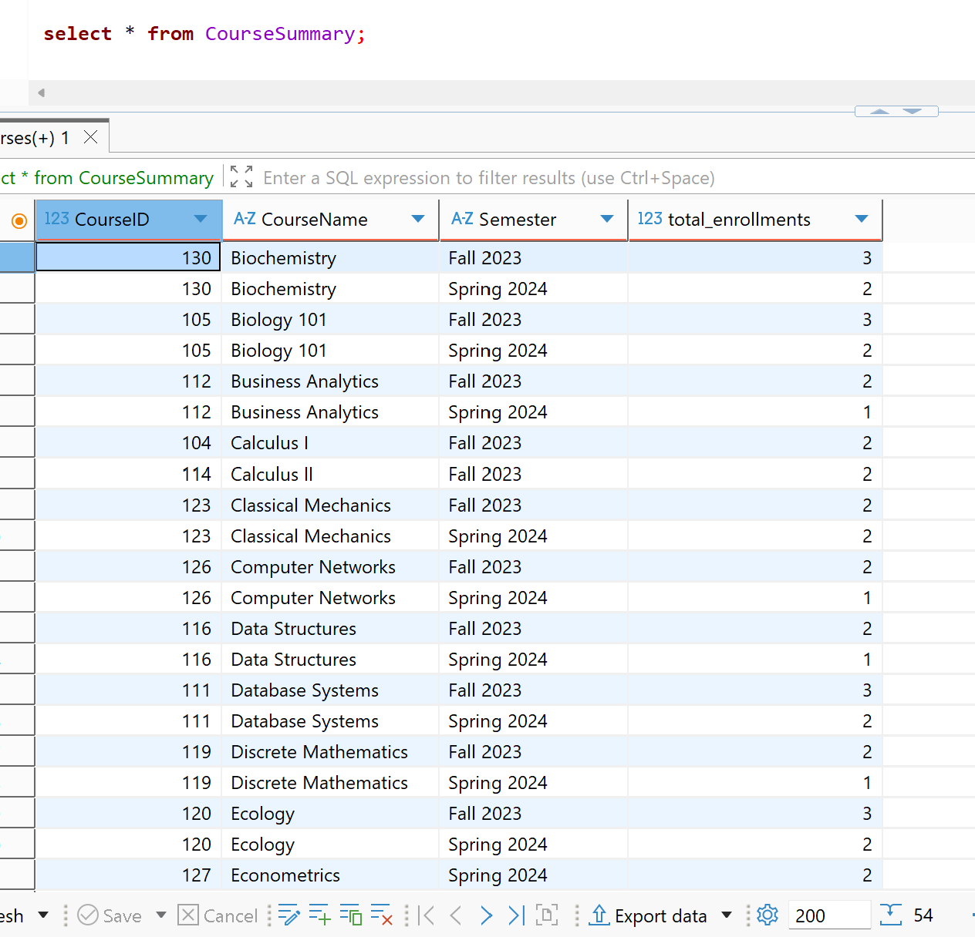

4. Update InstructorSchedule - Update InstructorSchedule to show only courses for the current semester
Step 1: Choose the current semester
The database does not store the current date, so I used the latest semester in the Enrollments table as the current semester. The data contains two semesters, Fall 2023 and Spring 2024. Since Spring 2024 is the most recent one, I treated it as the current semester.
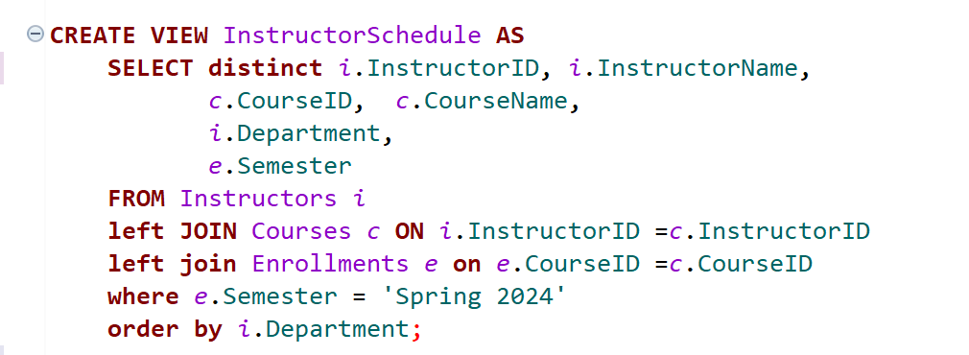
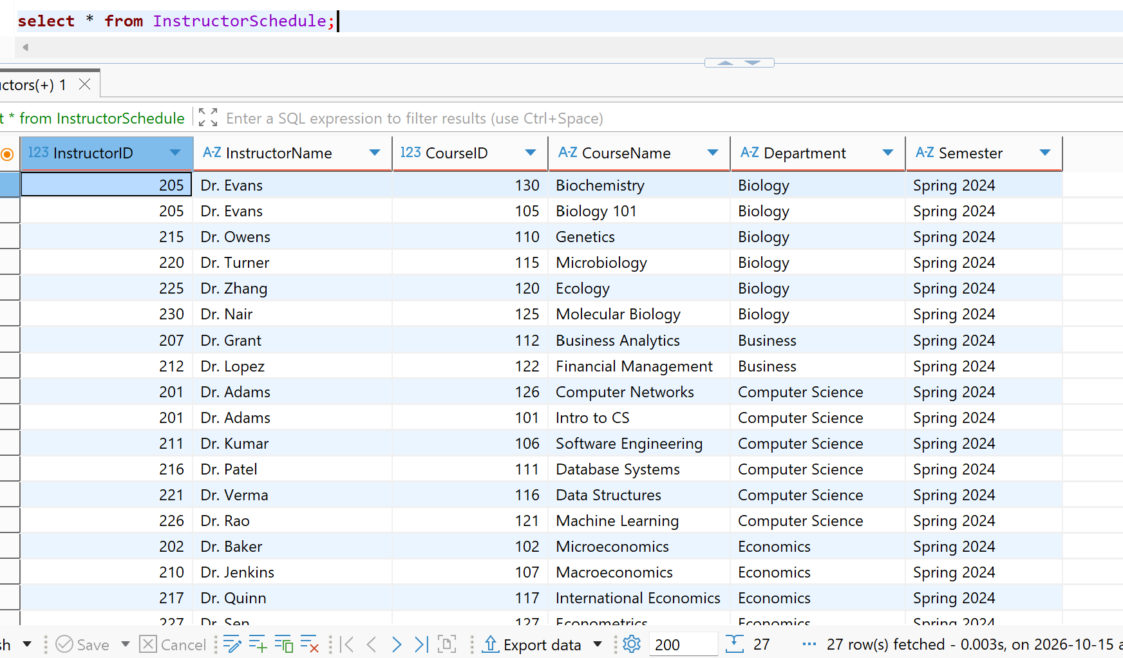

5. Create a view EligibleGraduates - Create a view EligibleGraduates that lists students eligible for graduation whose GPA is greater than or equal to 3.7
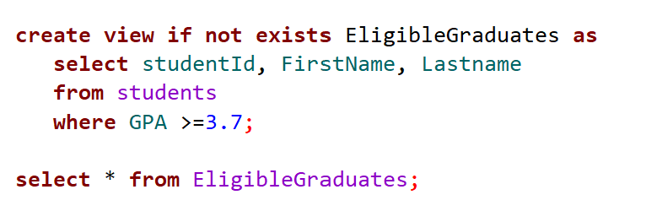
Result:
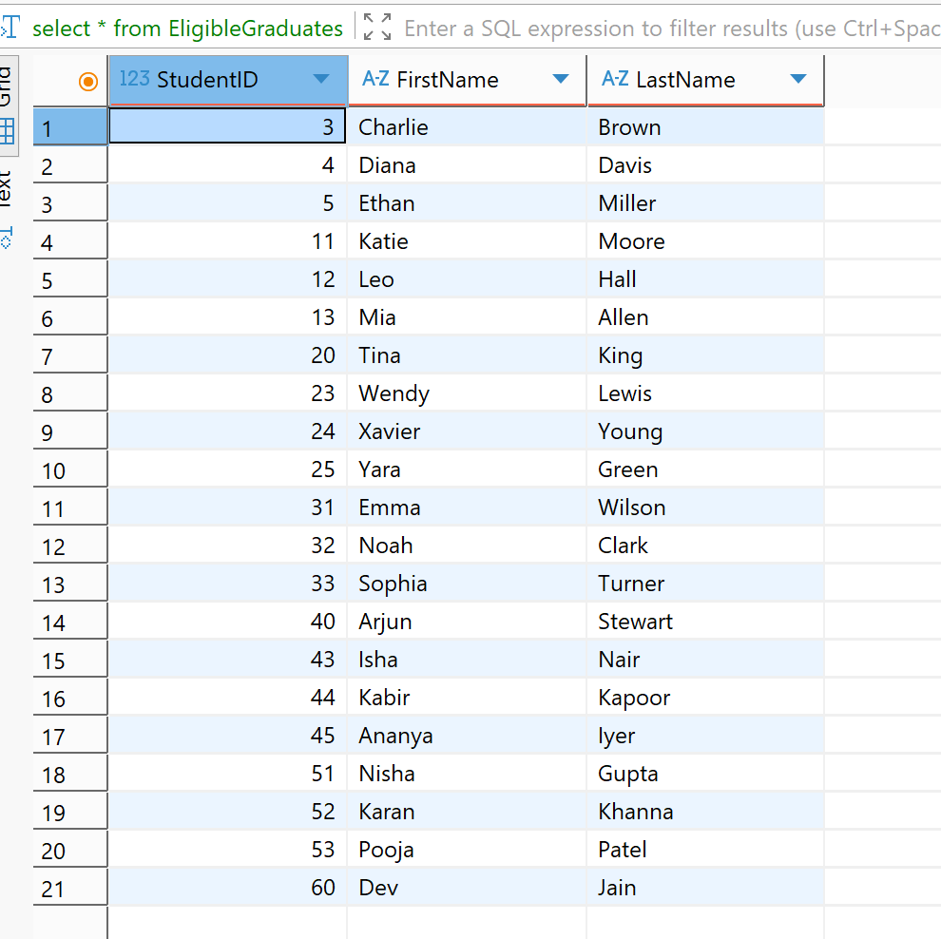

6. Alter EligibleGraduates
- Alter EligibleGraduates to include students' GPAs
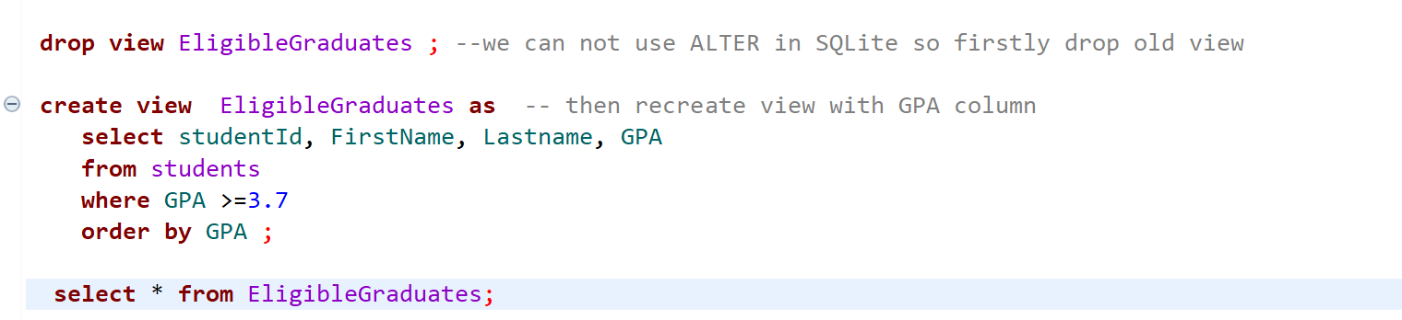

Result

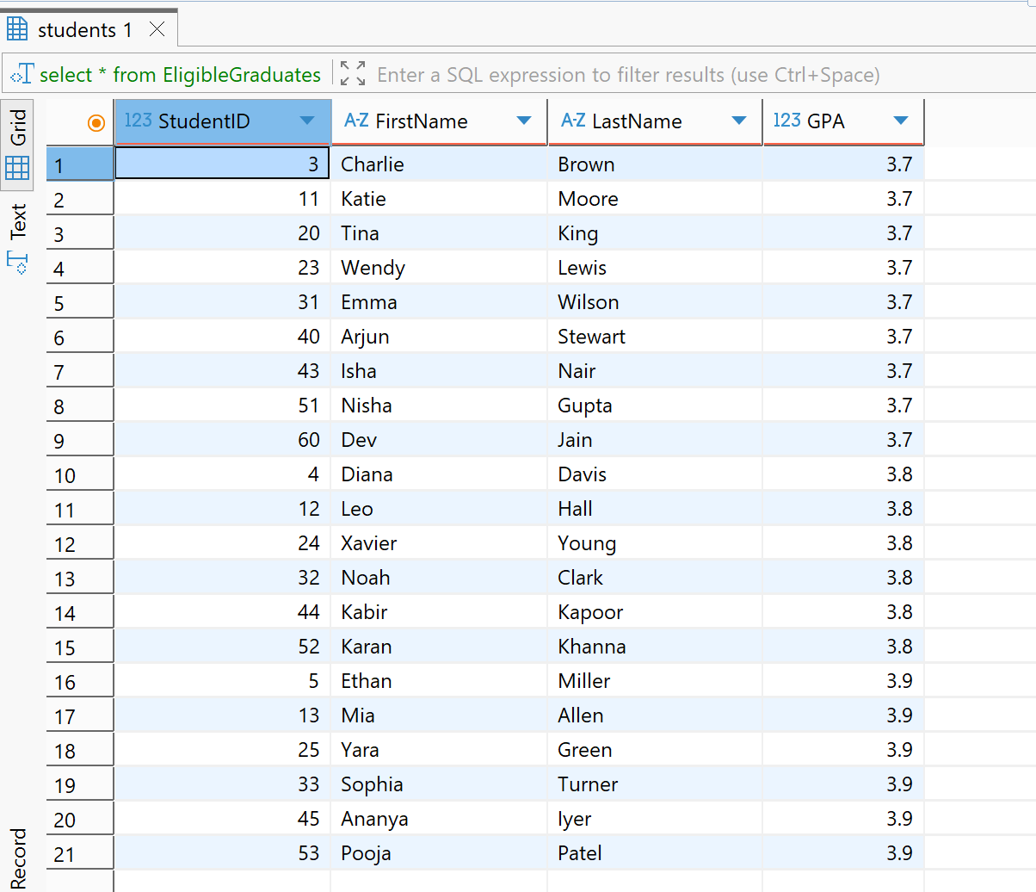

7. Rename CourseSummary
- Rename CourseSummary to CourseEnrolmentSummary

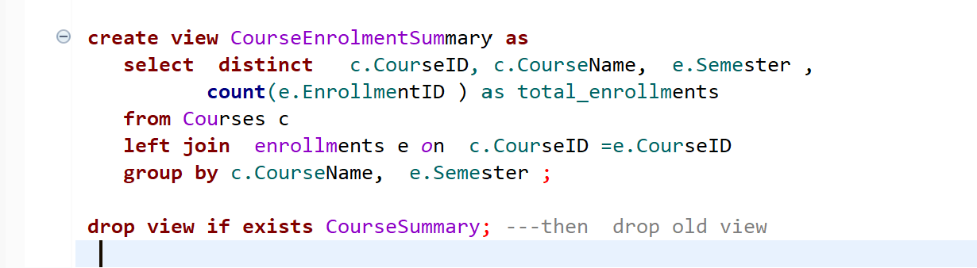

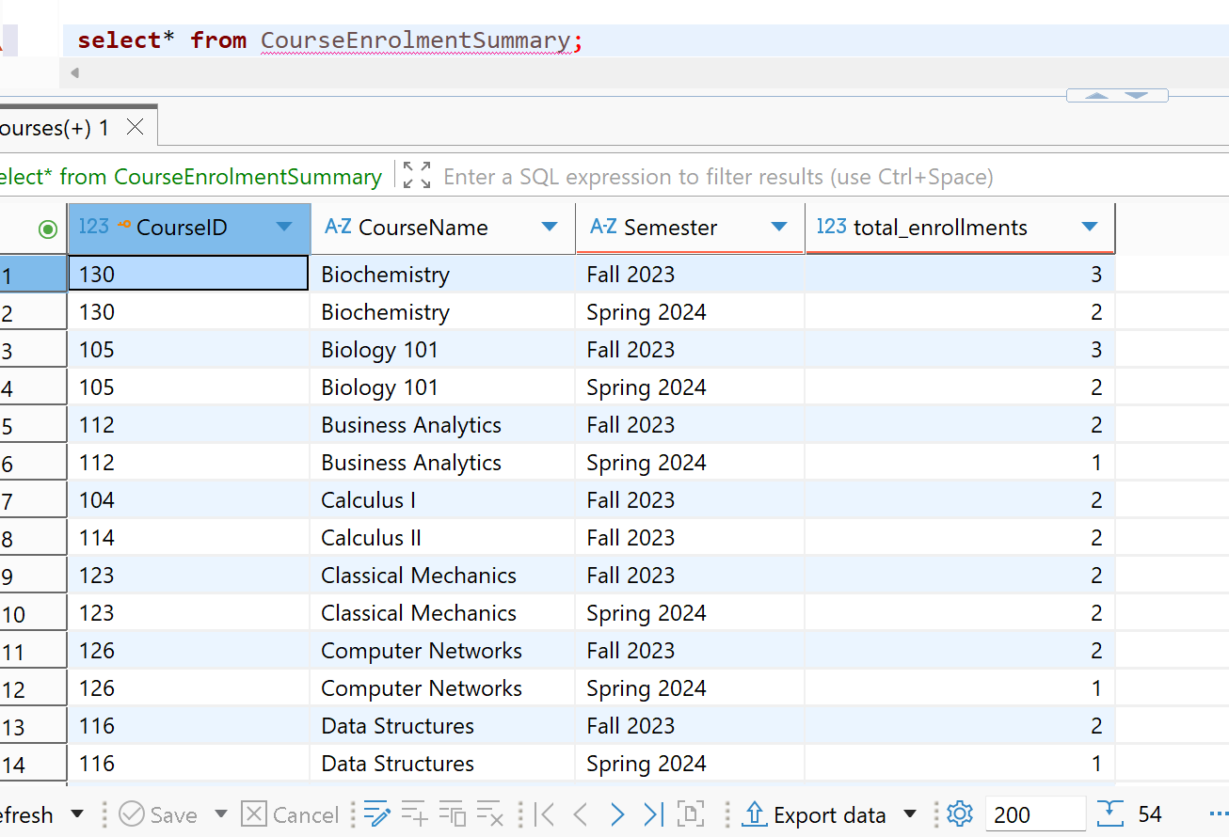

8. Drop view EligibleGraduates
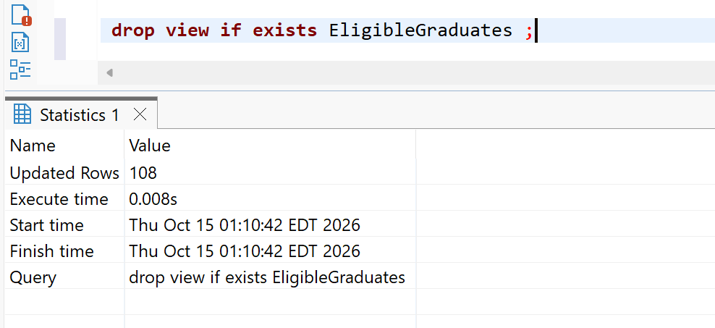

9. Create a CTE named SemesterCourses to list all courses offered in the current semester
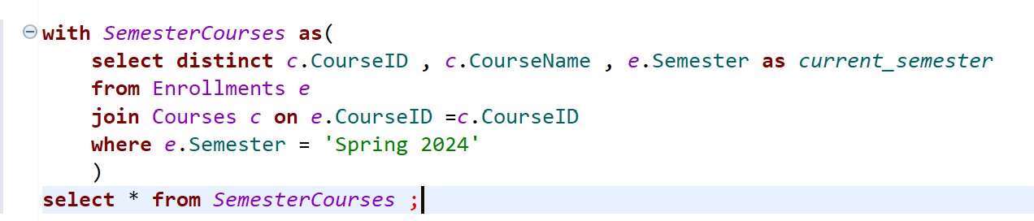

Result
